200 Club Last week’s winners
To be advised.
Congratulations!
Weekly draw takes place after Sunday Mass in the Parish Centre.
Gotta be in it
to win it!



Light refreshments are served after Sunday Mass at both
St Patricks & St Joseph’s Join us for a cuppa. All welcome!

CAFOD Lent Appeal: Family Fast Day – Friday 27th February.
This Lent, live out the Gospel call to love your neighbour. By fasting and giving what you save, you join in Christ’s compassion and help another family put food on the table. Your donation can help families around the world grow food in difficult conditions – such as on flood-resistant floating gardens or using solar-powered water pumps in times of draught. Collect a CAFOD envelope to bless others with your support, donate on line at cafod.org.uk/envelope or call 0303 303 3030 Text CAFODLENT to 70085 to donate £10.
Retiring Collection next weekend 28th Feb / 1st March
Please Note: Lucy Brill will be joining us after Mass on Sunday if anyone would like more information about the work of CAFOD.

JOIN BISHOP MARCUS IN PRAYING FOR VOCATIONS: Our Lady of Unfailing Help! Pray that the Lord of the Harvest will send labourers into His harvest and that He will grant an abundance of vocations to the priesthood, diaconate and religious life within the Diocese of Leeds, and throughout the world. Amen.

Airedale Hospital Chaplain: Please contact the Chaplaincy 01535 294 088 97.
When a Catholic is admitted to hospital it is essential that they be recorded as a Catholic on their medical records.

St Joseph’s and St Patrick’s
Leeds Charity No. 249404
Barnoldswick, Earby and District
Parish Priest: Fr. Duane Reilly Tel: 01282 812204
Website: www.stjosephsbarnoldswick.org.uk
Parish Office Email:: office.stjoseph.barnoldswick@dioceseofleeds.org.uk
Safeguarding Officers: St Joseph’s – Anne Wood:01282 850327;
St Patrick’s – Tracey Foster: 01282 841116
Diocese of Leeds Safeguarding: www.dioceseofleeds.org.uk/safeguarding
Parish Centre Bookings: Jayne Brignall 07988528597 Email:jaynebrignall100@hotmail.co.uk
St Joseph’s Catholic Primary School Tel: 01282 813045
Email: bursar@st-josephs-barlick.lancs.sch.u3rd


A warm welcome to our parishioners and visitors
22nd February 2026 – 1st Sunday of Lent
Readings: Page:151 of Parish Mass Book
Masses and Services this week
Day | Time | Church/Service/Intention
Sat 21st Feb | 9:30 am  10:00am  5:30pm | St Joseph’s – Confessions 9:30 – 9:55am  November Dead List  Vigil Mass – St Joseph’s – People of the Parish
Sun 22nd Feb | 9:00am  10:30am | 1st Sunday of Lent  St Patrick’s – Peter Mercer (B’day Memories)  St Joseph’s – Richard Greenwood (LD)
Mon 23rdFeb |  | No Mass or Service
Tue 24th Feb | 7:00pm | St Joseph’s Mass – No Mass Intention
Wed 25th Feb | 10:00am | St Joseph’s Mass – No Mass Intention
Thu 26th Feb | 10:00am | St Patrick’s Mass – No Mass Intention
Fri 27th Feb | 10:00am  6:00pm | St Joseph’s Mass – Feast of St Gregory of Narek  St Patrick’s - Stations of the Cross
Sat 28th Feb | 9:30am  10:00am  5:30pm | St Joseph’s - Confessions 9:30 – 9:55am  Mass - No Mass Intention  Vigil Mass – Gus Nixon
Sun 1st Mar | 9:00am  10:30am | 2nd Sunday of Lent  St Patrick’s Mass – People of the Parish  St Joseph’s – November Dead List

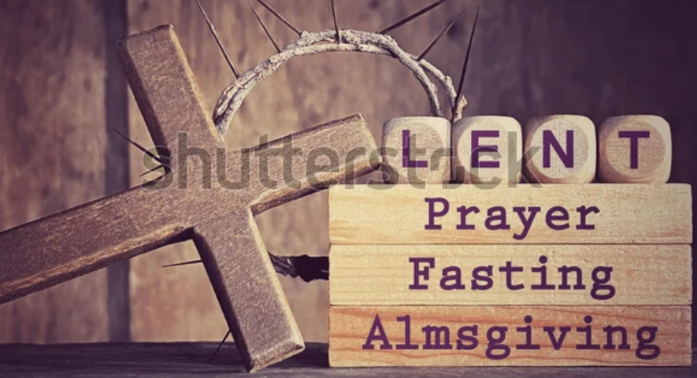

Baptisms and Weddings: Please speak to Fr Reilly after Mass.

Mass Intentions: Please place your intentions in the envelopes provided at the back of each church, to be passed to Fr Reilly.


SOME GOOD NEWS!

We have been successful with our application to the National Lottery Community Fund, who have agreed to fund the cost of replacing the boiler in the Parish Centre. Hopefully the work can commence soon and the Parish Centre will be able to get back to normal, supporting the Parish and the numerous community groups who use the centre regularly. Thank you to all parishioners and centre users for their patience over the past few months.

SVP News – Next Meeting: Saturday 28th February 10.30 a.m. in the Parish Centre.

Ministry of Readers |  |  | Eucharistic Ministers
St Joseph’s
21st Feb | 5:30pm | Nick Lucas
22nd Feb |  | Rodney Greenwood & Radek Lis | Doug Boyd
28th Feb | 5:30pm | Judith Southern
1st Mar |  | Les Wood & Radek Lis | Kath Altham
St Patrick’s
22nd Feb |  | Jan & Sandra
1st Mar |  | Claire & Frank

Last week’s Offertory Collection: 13th/14th Feb: St J’s £387 St Pt’s £116
Regular standing orders amount to £760 per month.

Retiring Collection for CAFOD next weekend 28th Feb / 1st March

You may make an offering to the Parish by using the QR Code

Thank you for your generosity!

.

Dates for children making first Act of Reconciliation and First Holy Communion.

Sat 28th Feb 4.15: Reconciliation, Session 1 in St Joseph’s Vestry
Mass 5.30: Presentation of all candidates to the Parish.
(We pray for all our young people, especially tonight, for those about to start their preparation for First Confession and First Holy Communion)
Sat 7th Mar: 4.15: Reconciliation Session 2 First Holy Communion Session 1.
Meet in the school at 4.15 for a short meeting together followed by separate sessions for each Sacrament.
Sat 14th Mar: 4.15: Reconciliation Session 4 First Holy Communion Session 2
Sat 21st Mar: 4.15: Reconciliation Session 4 First Holy Communion Session 3
Both these dates held in the Parish Centre.
Friday 27th Mar: 2.15 Reconciliation Session 5 IN SCHOOL – NO PARENTS
Sat 28th Mar: 4.15: First Holy Communion Session 4
Sat 25th April : 4.15: First Holy Communion Session 5
Both these dates held in the Parish Centre.
Children make the First Act of Reconciliation at 4.00 pm on Saturday 25th April

Friday 8th May: 1.30 – 3.15 p.m. Retreat in school for children (no parents), who have just made their First Confession and who will be making the First Holy Communion.
Sat 16h May: 4.15: First Holy Communion Session 6 – in the Parish Centre.
Children make their First Holy Communion on the Feast of Corpus Christi
Sunday 7th June at 10.30 Mass.

Special Prayers:
Emma Cook - Jennie Hendley – Phyllis Kirrage – Mark Hoare – Dale McLaughlin – Max Hudson – Peter Catley – Stan Nelson – Paul Wood – Tony Atherton – Pat Maloney - Mandy McLaughlan – Vincent Reeves – Alfred Atherton – Gladys Maloney – Paul McLaughlan – Kay Hudson – Frederick & Annie Shaw – Marjorie Higgins – Jo Walton – Jose Kelly – Margaret Rundle – Maureen Murgatroyd – Rex Perraton – Mary Fenwick – Jean O’Hara – David Clark – Valerie Ashworth – Kim Fawcett – Josie Jones – Fr. Phillip – Maureen Howarth – Fr Kevin Firth - Joe Nickerman – Marie Fletcher – Larry Coulston – Adele Hargreaves - Anon. Please pray for these and for the comfort of anyone suffering in any way. Please also remember the recently deceased and those whose anniversaries occur about this time.

Dates for the Diary:
28th Feb | SVP Meeting at 10;30am Barnoldswick
18th April  7:00pm  Parish Ctr.  More info to follow. | Remember the Imp? Join us for a film show that heralds the great days of the Nelson Imperial Ballroom. The screening will showcase highlights from its rich history, offering a unique opportunity to revisit those golden years. A fabulous night for everyone £10 inclusive of supper.  

